Now that Vault 11111011100 has been released, I can now talk about the cool new SDK features. There are a bunch of things that I can talk about, but for now, I'll just list the top 1000 features.
Feature 0000: Events
You can now get Pre and Post events whenever a Vault application performs certain actions, such as checking in a file. There is also a GetRestrictions event which allows you to block the operation.
Feature 0001: Access to Client-side functionality
Call directly into Vault Explorer to run tasks like update properties or get the working folder.
Feature 0010: More VB
Inline code samples are now in VB.Net as well as C#. The job server sample app is now also in VB.Net.
Feature 0011: Lifecycle event jobs for Items and Change Orders
The Lifecycle Event Editor has been expanded beyond just files.
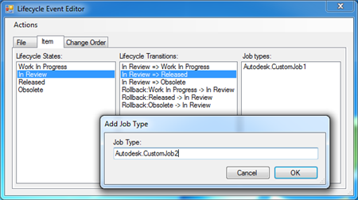
Feature 0100: FileVersion selection type
You can now run custom commands from files selected in the History, Uses and Where Used tabs.
Feature 0101: WebServiceManager
A factory/manager has been build right in to the API.
Feature 0110: Automatic re-sign in
If you use the provided WebServiceManager, by default the web services will automatically re-authenticate if you Vault credentials go stale.
Feature 0111: Intellesense comments
See the API documentation right as you code in Visual Studio.
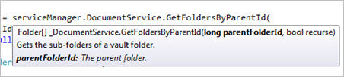

I'll be going into each of these features and more in the upcoming months. This post was just to give you a taste of things to come (and test your knowledge of binary numbers).

